**ML DEVELOPMENT PROCESS**

**ITERATIVE LOOP OF ML DEVELOPMENT**

**Iterative loop of machine learning development**

* **The process begins with selecting the overall architecture, including the machine learning model, data, and hyperparameters.**
* **After implementing and training the model, diagnostics such as bias and variance analysis are performed to guide further improvements.**

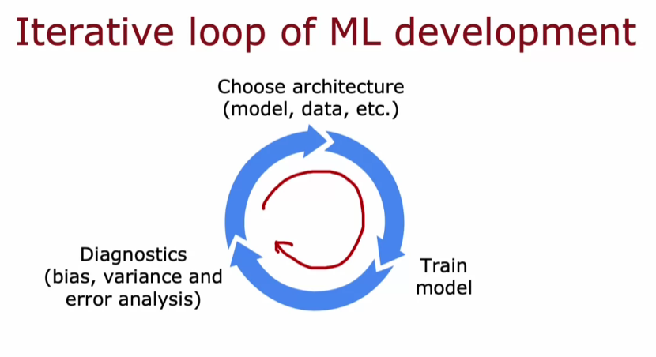

**Building a spam classifier example**

* **A supervised learning algorithm can be trained to classify emails as spam or non-spam based on features derived from the email content.**
* **Features can be constructed using the presence of specific words or by counting their occurrences, which helps in training classification algorithms like logistic regression or neural networks.**

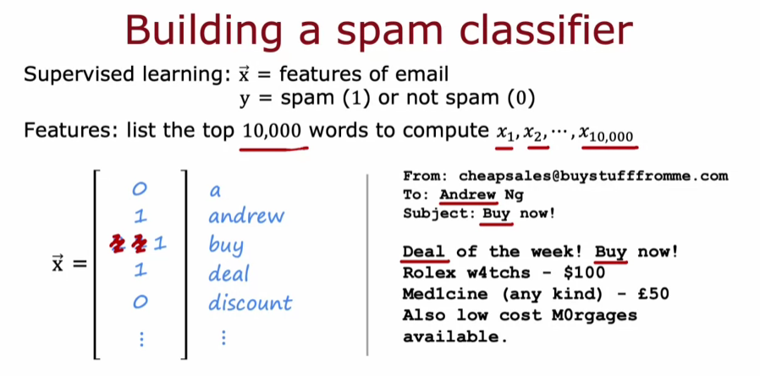

**Improving model performance**

* **If the initial model performance is unsatisfactory, various strategies can be explored, such as collecting more data or developing sophisticated features based on email routing and content.**
* **Understanding whether the model suffers from high bias or high variance is crucial in deciding the most effective direction for improvement.**

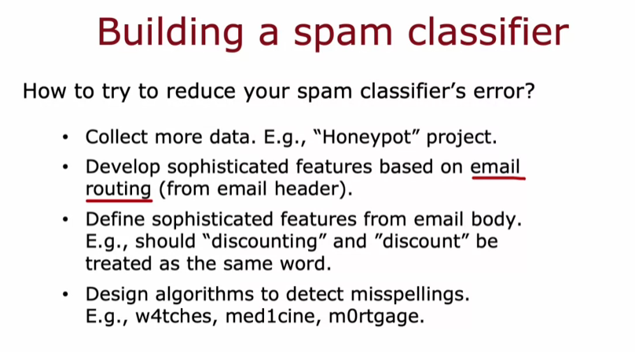

**ERROR ANALYSIS**

**Understanding Bias and Variance**

* **Bias refers to the error due to overly simplistic assumptions in the learning algorithm, while variance refers to the error due to excessive complexity. Balancing these two is crucial for optimal model performance.**
* **Conducting a bias-variance analysis helps determine whether collecting more data will be beneficial for the learning algorithm.**

**Error Analysis Process**

* **Error analysis involves manually reviewing misclassified examples to identify common patterns or traits that lead to errors, such as specific types of spam emails.**
* **By categorizing misclassified examples, you can prioritize which issues to address first, focusing on those that have the most significant impact on performance.**

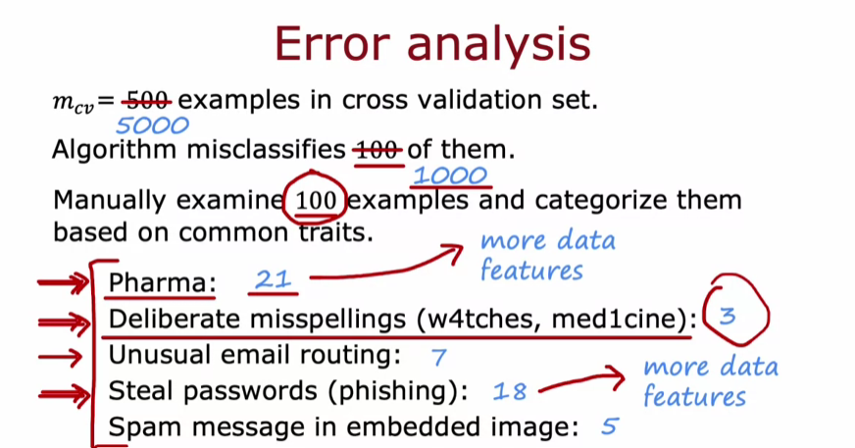

**ADDING DATA**

**Targeted Data Collection**

* **Instead of gathering all types of data, focus on collecting more data from specific areas where the algorithm is underperforming, such as particular spam types.**
* **Conducting error analysis can help identify which subsets of data need more examples to improve the algorithm's performance.**

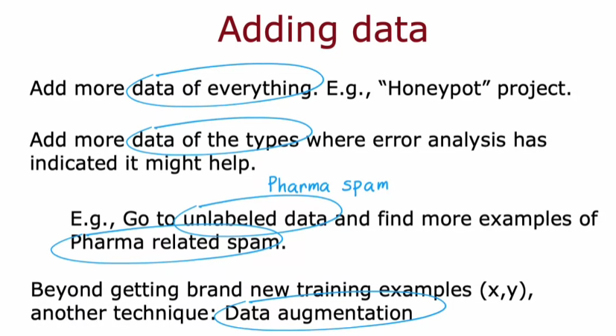

**Data Augmentation Techniques**

* **Data augmentation involves modifying existing training examples to create new ones, such as rotating or altering images while preserving their labels.**
* **This technique is also applicable to audio data, where background noise can be added to original clips to create diverse training examples.**

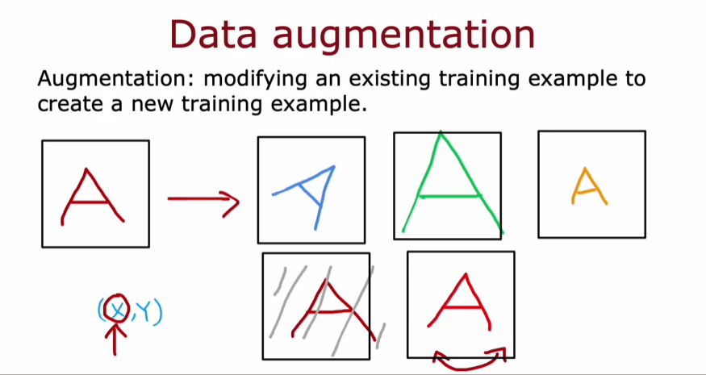

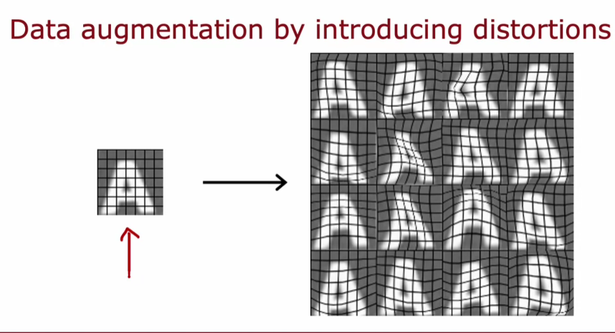

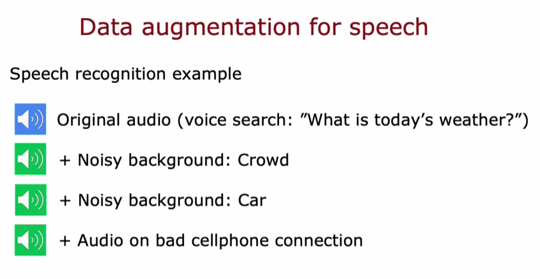

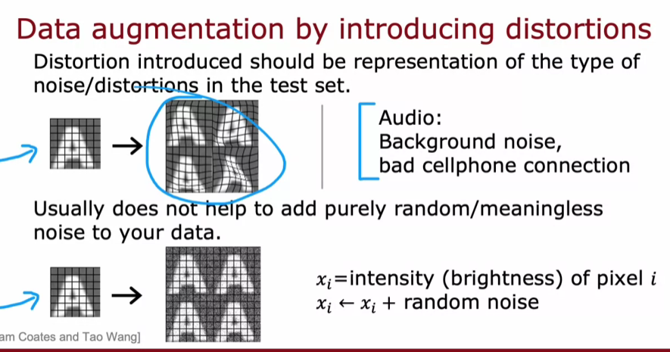

**Synthetic Data Generation**

* **Synthetic data generation creates entirely new examples from scratch, which can be particularly useful in tasks like optical character recognition (OCR).**
* **By using different fonts and styles in a text editor, you can generate a large number of realistic training images for OCR tasks, boosting the algorithm's performance.**

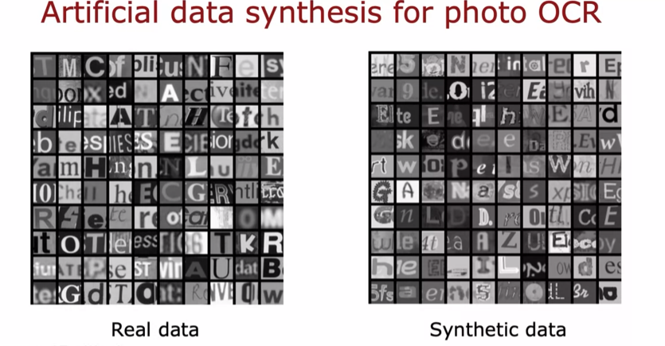

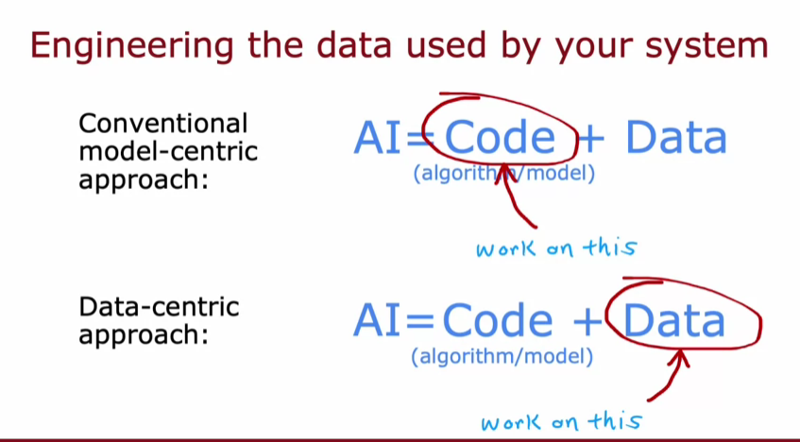

**TRANSFER LEARNING (USING DATA FROM DIFFERENT TASK)**

**Understanding Transfer Learning**

* **Transfer learning enables the use of a pre-trained neural network on a large dataset (e.g., images of various objects) to assist in a different but related task (e.g., recognizing handwritten digits).**
* **The process involves copying the parameters from the initial layers of the pre-trained model while replacing the output layer to fit the new task.**

**Training Options in Transfer Learning**

* **Option 1: Only train the new output layer's parameters while keeping the earlier layers fixed, which is beneficial for very small datasets.**
* **Option 2: Fine-tune all parameters, initializing the first layers with pre-trained values, which can be more effective with larger datasets.**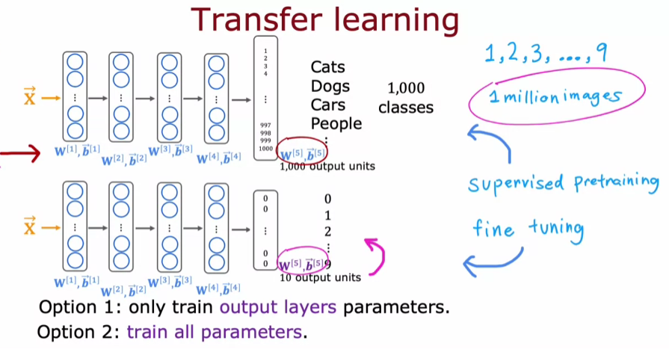

**Benefits and Community Impact**

* **Transfer learning works because early layers of neural networks learn generic features (like edges and shapes) that are useful across different tasks.**
* **The machine learning community benefits from shared pre-trained models, allowing individuals to build on each other's work and achieve better results with less effort.**

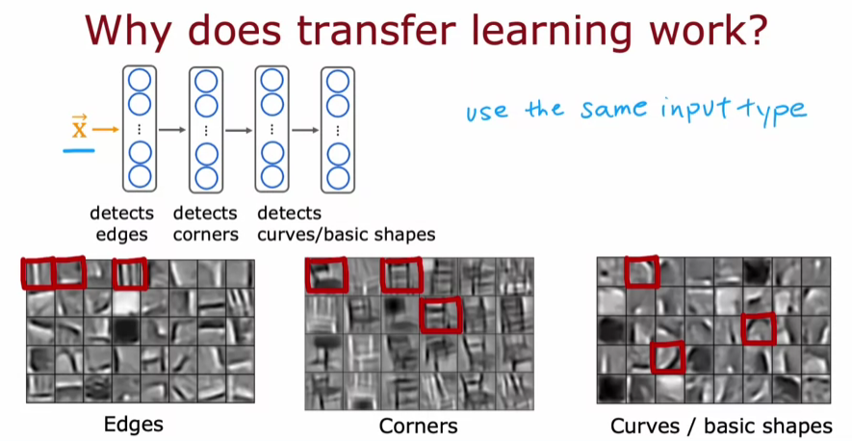

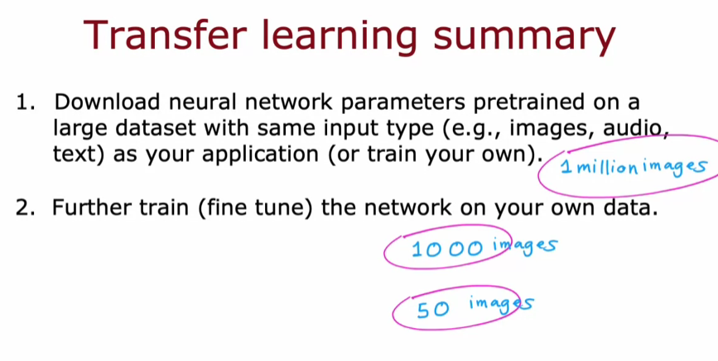

**FULL CYCLE OF ML PROJECT**

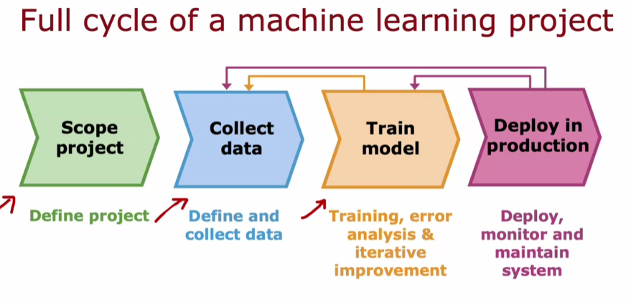

**Project Scoping**

* **The first step is to define the project, such as developing a speech recognition system for voice search.**
* **Clearly identifying the project helps in planning the subsequent steps effectively.**

**Data Collection and Model Training**

* **After scoping, the next step is to collect the necessary data, including audio and transcripts for training.**
* **Once data is collected, the model is trained, followed by error analysis to identify areas for improvement, which may lead to additional data collection.**

**Deployment and Maintenance**

* **After achieving satisfactory model performance, the model is deployed in a production environment, often through an inference server.**
* **Continuous monitoring and maintenance are crucial to ensure the model remains effective, allowing for updates and improvements based on user data and performance metrics.**

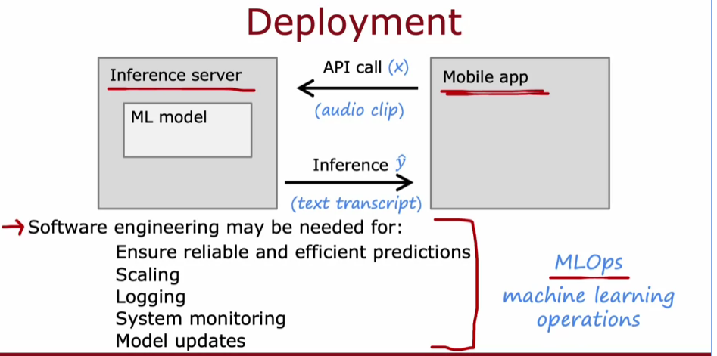

**FAIRNESS, BIAS AND ETHICS**

**Ethical considerations in machine learning**

* **Machine learning systems can exhibit bias, as seen in examples like hiring tools that discriminate against women and facial recognition systems that misidentify darker-skinned individuals.**
* **Developers are urged to consider the ethical implications of their work and to avoid projects that could harm society.**

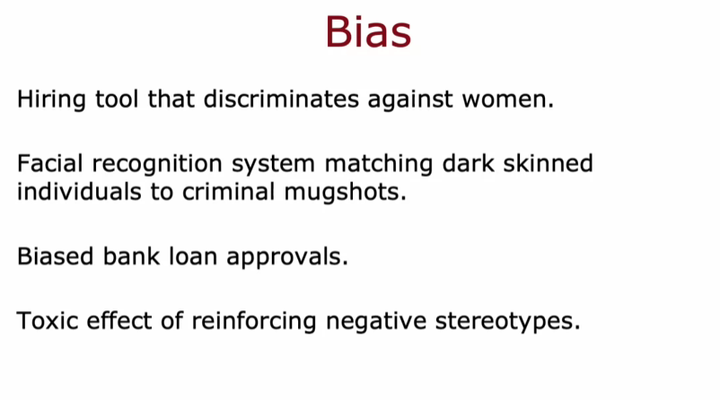

**Strategies for reducing bias and ensuring fairness**

* **Assemble diverse teams to brainstorm potential issues and harms, as diversity can lead to better identification of problems.**
* **Conduct literature searches for industry standards and guidelines to inform the development of fair and unbiased systems.**

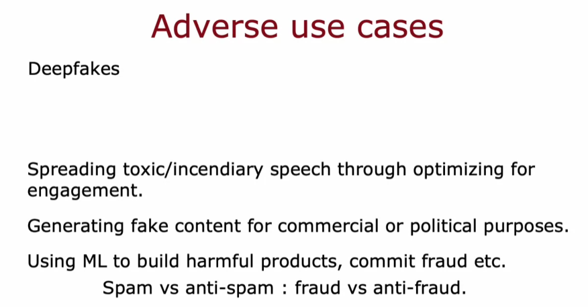

**Monitoring and mitigation plans**

* **Audit systems for bias before deployment and develop mitigation plans to address any identified issues.**
* **Continuous monitoring after deployment is essential to quickly address any problems that arise, ensuring the system remains fair and ethical.**

